SMART DELIVERY OPERATIONS ANALYTICS SYSTEM

SQL PROJECT REPORT

Submitted by
Pothuru Kavya Sree

Technology:

- MySQL 8.0
- MySQL Workbench
- SQL

Table of Contents:

- Introduction
- Project Objectives
- Dataset Description
- Database Design (ER Diagram)
- Database Schema
- Data Import and Validation
- Data Cleaning
- SQL Analysis
- Business Insights
- Recommendations
- Conclusion

- Introduction

The Smart Delivery Operations Analytics System is a SQL-based analytical project designed to manage and analyze food delivery operations. The project demonstrates database design, data cleaning, SQL querying, and business reporting using a real-world delivery dataset.

The system stores information about customers, restaurants, delivery partners, orders, payments, ratings, and promotions. SQL is used to generate insights that help management improve operational efficiency, customer satisfaction, and business profitability.

- Project Objectives

The objectives of this project are:

- Design a normalized relational database.
- Import CSV files into MySQL.
- Validate imported data.
- Clean inconsistent and missing data.
- Perform business analysis using SQL.
- Generate business insights.
- Recommend solutions to improve operations.

- Dataset Description

The project consists of seven interconnected tables used to analyze delivery operations, customer behaviour, revenue, and partner performance.

Table | Description
Customers | Stores customer information including name, age, gender, city, and signup date.
Restaurants | Stores restaurant details such as restaurant name, cuisine type, and city.
Delivery Partners | Contains delivery partner information.
Orders | Stores order details including order time, delivery time, order amount, and status.
Payments | Contains payment transaction details for each order.
Ratings | Stores customer ratings and reviews for completed orders.
Customer Behaviour | Derived analytics table containing customer behaviour metrics such as total orders, total spending, average order value, days since last order, and churn status.
Total records imported:

Customers – 1,000
Restaurants – 100
Delivery Partners – 200
Orders – 10,000
Payments – 10,000
Ratings – 7,000
Customer Behaviour – 1000

Overall dataset size: 29,300+ records

- Database Design (ER Diagram)

The database was designed using normalization principles.

Entities

Customers
Restaurants
Delivery Partners
Orders
Payments
Ratings
Customer Behaviour

Relationships

One Customer → Many Orders
One Restaurant → Many Orders
One Delivery Partner → Many Orders
One Order → One Payment
One Order → One Rating

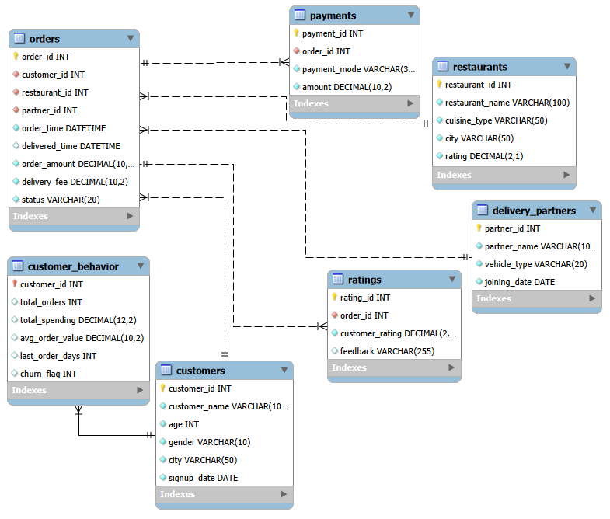

5. Database Schema

Each table was created using SQL DDL.
The schema includes:

Primary Keys
Foreign Keys
NOT NULL Constraints
CHECK Constraints
Appropriate Data Types

Create Database:

create database smart_delivery;
use smart_delivery;

Create Table:

1. CUSTOMERS

CREATE TABLE customers (
customer_id INT NOT NULL,
customer_name VARCHAR(100) NOT NULL,
age INT NOT NULL,
gender VARCHAR(10) NOT NULL,
city VARCHAR(50) NOT NULL,
signup_date DATE NOT NULL,

CONSTRAINT pk_customers
PRIMARY KEY (customer_id),

CONSTRAINT chk_customer_age
CHECK (age BETWEEN 18 AND 100),

CONSTRAINT chk_customer_gender
CHECK (gender IN ('Male','Female','Other'))
);

2. RESTAURANTS

CREATE TABLE restaurants (
restaurant_id INT NOT NULL,
restaurant_name VARCHAR(100) NOT NULL,
cuisine_type VARCHAR(50) NOT NULL,
city VARCHAR(50) NOT NULL,
rating DECIMAL(2,1) NOT NULL,

CONSTRAINT pk_restaurants
PRIMARY KEY (restaurant_id),

CONSTRAINT chk_restaurant_rating
CHECK (rating BETWEEN 1.0 AND 5.0)
);

3. DELIVERY_PARTNERS

CREATE TABLE delivery_partners (
partner_id INT NOT NULL,
partner_name VARCHAR(100) NOT NULL,
vehicle_type VARCHAR(20) NOT NULL,
joining_date DATE NOT NULL,

CONSTRAINT pk_delivery_partners
PRIMARY KEY (partner_id),

CONSTRAINT chk_vehicle_type
CHECK (vehicle_type IN
('Bike','Scooter','Bicycle','Electric Bike'))
);

4. ORDERS

CREATE TABLE orders (
order_id INT NOT NULL,
customer_id INT NOT NULL,
restaurant_id INT NOT NULL,
partner_id INT NOT NULL,
order_time DATETIME NOT NULL,
delivered_time DATETIME,
order_amount DECIMAL(10,2) NOT NULL,
delivery_fee DECIMAL(10,2) NOT NULL,
status VARCHAR(20) NOT NULL,

CONSTRAINT pk_orders
PRIMARY KEY (order_id),

CONSTRAINT fk_orders_customer
FOREIGN KEY (customer_id)
REFERENCES customers(customer_id),

CONSTRAINT fk_orders_restaurant
FOREIGN KEY (restaurant_id)
REFERENCES restaurants(restaurant_id),

CONSTRAINT fk_orders_partner
FOREIGN KEY (partner_id)
REFERENCES delivery_partners(partner_id),

CONSTRAINT chk_order_amount
CHECK (order_amount > 0),

CONSTRAINT chk_delivery_fee
CHECK (delivery_fee >= 0),

CONSTRAINT chk_order_status
CHECK (status IN
('Delivered','Cancelled','Pending'))
);

5. PAYMENTS

CREATE TABLE payments (
payment_id INT NOT NULL,
order_id INT NOT NULL,
payment_mode VARCHAR(30) NOT NULL,
amount DECIMAL(10,2) NOT NULL,

CONSTRAINT pk_payments
PRIMARY KEY (payment_id),

CONSTRAINT fk_payments_order
FOREIGN KEY (order_id)
REFERENCES orders(order_id),

CONSTRAINT chk_payment_amount
CHECK (amount > 0),

CONSTRAINT chk_payment_mode
CHECK (payment_mode IN
('UPI',
'Credit Card',
'Debit Card',
'Cash on Delivery',
'Wallet'))
);

6. RATINGS

CREATE TABLE ratings (
rating_id INT NOT NULL,
order_id INT NOT NULL,
customer_rating DECIMAL(2,1) NOT NULL,
feedback VARCHAR(255),

CONSTRAINT pk_ratings
PRIMARY KEY (rating_id),

CONSTRAINT fk_ratings_order
FOREIGN KEY (order_id)
REFERENCES orders(order_id),

CONSTRAINT chk_customer_rating
CHECK (customer_rating BETWEEN 1.0 AND 5.0)
);

7. CUSTOMER_BEHAVIOR

CREATE TABLE customer_behavior (
customer_id INT NOT NULL,
total_orders INT DEFAULT 0,
total_spending DECIMAL(12,2) DEFAULT 0,
avg_order_value DECIMAL(10,2),
last_order_days INT,
churn_flag INT,

CONSTRAINT pk_customer_behavior
PRIMARY KEY (customer_id),

CONSTRAINT fk_cb_customer
FOREIGN KEY (customer_id)
REFERENCES customers(customer_id),

CONSTRAINT chk_total_orders
CHECK (total_orders >= 0),

CONSTRAINT chk_total_spending
CHECK (total_spending >= 0),

CONSTRAINT chk_avg_order_value
CHECK (avg_order_value >= 0),

CONSTRAINT chk_last_order_days
CHECK (last_order_days >= 0),

CONSTRAINT chk_churn_flag
CHECK (churn_flag IN (0,1))
);

6. Data Import and Validation

All CSV files were successfully imported into MySQL using the Import Wizard.

LOAD DATA LOCAL INFILE 'C:/Users/LENOVO/OneDrive/Desktop/D13/sql/D13_SQL_Project/customers.csv'
INTO TABLE customers
FIELDS TERMINATED BY ','
ENCLOSED BY '"'
LINES TERMINATED BY '\r\n'
IGNORE 1 ROWS;

LOAD DATA LOCAL INFILE 'C:/Users/LENOVO/OneDrive/Desktop/D13/sql/D13_SQL_Project/restaurants.csv'
INTO TABLE restaurants
FIELDS TERMINATED BY ','
ENCLOSED BY '"'
LINES TERMINATED BY '\r\n'
IGNORE 1 ROWS;

LOAD DATA LOCAL INFILE 'C:/Users/LENOVO/OneDrive/Desktop/D13/sql/D13_SQL_Project/delivery_partners.csv'
INTO TABLE delivery_partners
FIELDS TERMINATED BY ','
ENCLOSED BY '"'
LINES TERMINATED BY '\r\n'
IGNORE 1 ROWS;

LOAD DATA LOCAL INFILE 'C:/Users/LENOVO/OneDrive/Desktop/D13/sql/D13_SQL_Project/orders.csv'
INTO TABLE orders
FIELDS TERMINATED BY ','
ENCLOSED BY '"'
LINES TERMINATED BY '\r\n'
IGNORE 1 ROWS;

LOAD DATA LOCAL INFILE 'C:/Users/LENOVO/OneDrive/Desktop/D13/sql/D13_SQL_Project/payments.csv'
INTO TABLE payments
FIELDS TERMINATED BY ','
ENCLOSED BY '"'
LINES TERMINATED BY '\r\n'
IGNORE 1 ROWS;

LOAD DATA LOCAL INFILE 'C:/Users/LENOVO/OneDrive/Desktop/D13/sql/D13_SQL_Project/ratings.csv'
INTO TABLE ratings
FIELDS TERMINATED BY ','
ENCLOSED BY '"'
LINES TERMINATED BY '\r\n'
IGNORE 1 ROWS;

LOAD DATA LOCAL INFILE 'C:/Users/LENOVO/OneDrive/Desktop/D13/sql/D13_SQL_Project/customer_behavior.csv'
INTO TABLE customer_behavior
FIELDS TERMINATED BY ','
ENCLOSED BY '"'
LINES TERMINATED BY '\r\n'
IGNORE 1 ROWS;

Validate Record Counts:

Validation was performed after each import using:

SELECT COUNT(*) FROM customers;
SELECT COUNT(*) FROM restaurants;
SELECT COUNT(*) FROM delivery_partners;
SELECT COUNT(*) FROM orders;
SELECT COUNT(*) FROM payments;
SELECT COUNT(*) FROM ratings;
SELECT COUNT(*) FROM customer_behavior;
The record counts matched the source CSV files, confirming successful import.

7. Data Cleaning

Several data quality issues were identified and resolved.

NULL Values

SELECT * FROM customers
WHERE customer_name IS NULL
OR city IS NULL
OR signup_date IS NULL;

SELECT * FROM restaurants
WHERE restaurant_name IS NULL
OR city IS NULL
OR cuisine_type IS NULL;

SELECT * FROM delivery_partners
WHERE partner_name IS NULL
OR vehicle_type IS NULL;

SELECT *FROM payments
WHERE payment_mode IS NULL
OR amount IS NULL;

SELECT *FROM ratings
WHERE customer_rating IS NULL;

SELECT *FROM customer_behavior
WHERE total_orders IS NULL
OR total_spending IS NULL;

SELECT *FROM orders
WHERE delivered_time IS NULL;

UPDATE orders
SET delivered_time = NULL
WHERE status IN ('Pending', 'Cancelled');

SELECT status, COUNT(*) AS total_orders
FROM orders
WHERE delivered_time IS NULL
GROUP BY status;

SELECT *FROM orders
WHERE status='Delivered'
AND delivered_time IS NULL;

Missing delivery timestamps were found only for Pending and Cancelled orders.

Duplicate Records
Duplicates were identified using:

SELECT customer_id, COUNT(*)
FROM customers
GROUP BY customer_id
HAVING COUNT(*)>1;

SELECT restaurant_id, COUNT(*)
FROM restaurants
GROUP BY restaurant_id
HAVING COUNT(*)>1;

SELECT order_id, COUNT(*)
FROM orders
GROUP BY order_id
HAVING COUNT(*)>1;

SELECT payment_id, COUNT(*)
FROM payments
GROUP BY payment_id
HAVING COUNT(*)>1;

SELECT partner_id, COUNT(*)
FROM delivery_partners
GROUP BY partner_id
HAVING COUNT(*)>1;

No duplicate primary keys were found.

Rating Validation
Ratings were validated using:

SELECT *
FROM restaurants
WHERE rating NOT BETWEEN 1 AND 5;

SELECT *
FROM ratings
WHERE customer_rating NOT BETWEEN 1 AND 5;

All ratings were within the valid range.

City Standardization
City names were validated using:

SELECT DISTINCT city
FROM customers
ORDER BY city;

SELECT DISTINCT city
FROM restaurants
ORDER BY city;

Validate Referential Integrity

Orders → Customers
SELECT *
FROM orders o
LEFT JOIN customers c
ON o.customer_id=c.customer_id
WHERE c.customer_id IS NULL;

Orders → Restaurants
SELECT *
FROM orders o
LEFT JOIN restaurants r
ON o.restaurant_id=r.restaurant_id
WHERE r.restaurant_id IS NULL;

Orders → Delivery Partners
SELECT *
FROM orders o
LEFT JOIN delivery_partners d
ON o.partner_id=d.partner_id
WHERE d.partner_id IS NULL;

Payments → Orders
SELECT *
FROM payments p
LEFT JOIN orders o
ON p.order_id=o.order_id
WHERE o.order_id IS NULL;

Ratings → Orders
SELECT *
FROM ratings r
LEFT JOIN orders o
ON r.order_id=o.order_id
WHERE o.order_id IS NULL;

Data Validation
Final validation confirmed:

- No duplicate primary keys.
- Valid foreign key relationships.
- Valid ratings.
- Correct delivery timestamps.
- Consistent city names.

8. SQL Analysis
More than 40 SQL queries were executed.

The queries covered:

Delivery Performance
Examples:
Longest average delivery time
Fastest delivery partners
Cities with delivery delays

Cancellation Analysis
Examples:
Highest cancellation restaurants
Peak cancellation day
Peak cancellation time

Revenue Analysis
Examples:
Monthly revenue
Top restaurants
Top cities
Payment methods

Customer Analysis
Examples:
Top spending customers
Inactive customers
Frequent customers
Churn analysis

Delivery Partner Analysis
Examples:
Fastest partners
Highest completed deliveries
Average ratings
Partner performance

The project includes SQL concepts such as:
SELECT
GROUP BY
HAVING
JOIN
Subqueries
CTE
Window Functions
Stored Procedures

9. Business Insights

Delivery Delays
Q1 Which restaurants are associated with the longest average delivery times?
SELECT
r.restaurant_id,
r.restaurant_name,
ROUND(AVG(TIMESTAMPDIFF(MINUTE,
o.order_time,
o.delivered_time)), 2) AS avg_delivery_time_minutes
FROM orders o
INNER JOIN restaurants r
ON o.restaurant_id = r.restaurant_id
WHERE o.status = 'Delivered'
GROUP BY r.restaurant_id, r.restaurant_name
ORDER BY avg_delivery_time_minutes DESC;
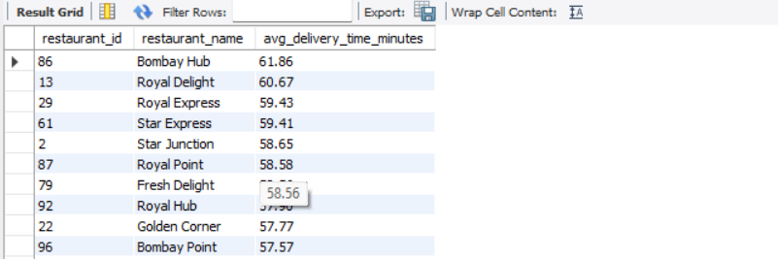
Business Insight
Restaurants with the highest average delivery times may have slower food preparation or inefficient order handling. These delays negatively affect customer satisfaction.
Recommendation
- Improve kitchen preparation efficiency.
- Monitor restaurant performance regularly.
- Optimize order processing.
Q2 Which delivery partners have the highest average time per order?
SELECT
d.partner_id,
d.partner_name,
ROUND(AVG(TIMESTAMPDIFF(MINUTE,
o.order_time,
o.delivered_time)),2) AS average_delivery_time_minutes
FROM orders o
INNER JOIN delivery_partners d
ON o.partner_id = d.partner_id
WHERE o.status = 'Delivered'
GROUP BY
d.partner_id,
d.partner_name
ORDER BY average_delivery_time_minutes DESC;
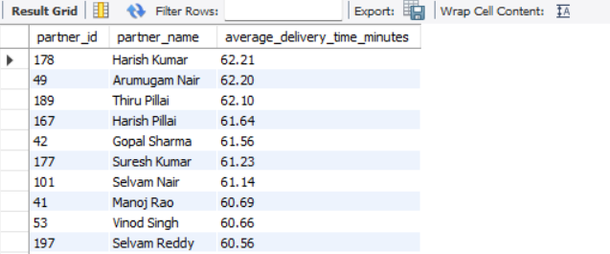
Business Insight
Some delivery partners consistently take longer to complete deliveries, indicating possible route or workload inefficiencies.
Recommendation
- Provide route optimization.
- Balance delivery assignments.
- Offer additional training.

Q3 Which cities experience the most delivery delays?
SELECT
c.city,
ROUND(AVG(TIMESTAMPDIFF(MINUTE,
o.order_time,
o.delivered_time)),2) AS average_delivery_delay_minutes
FROM orders o
INNER JOIN customers c
ON o.customer_id = c.customer_id
WHERE o.status = 'Delivered'
GROUP BY c.city
ORDER BY average_delivery_delay_minutes DESC;
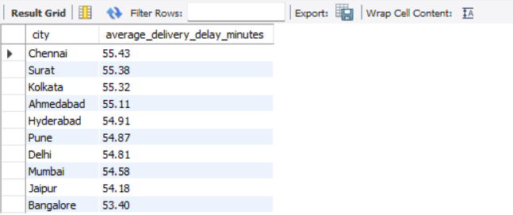
Business Insight
Cities with higher average delivery times may experience traffic congestion or insufficient delivery partner availability.
Recommendation
- Increase delivery partners in those cities.
- Improve delivery planning.
- Analyze peak-hour demand.

Q4 Are delivery delays increasing or decreasing over time?
SELECT
YEAR(o.order_time) AS year,
MONTH(o.order_time) AS month,
COUNT(o.order_id) AS total_orders,
ROUND(AVG(TIMESTAMPDIFF(MINUTE,
o.order_time,
o.delivered_time)),2) AS average_delivery_time_minutes
FROM orders o
WHERE o.status = 'Delivered'
GROUP BY
YEAR(o.order_time),
MONTH(o.order_time)
ORDER BY
year,month;
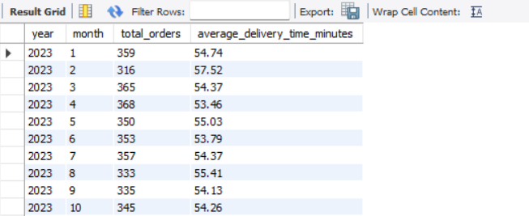
Business Insight
Monthly delivery trends reveal whether operational performance is improving or declining over time.
Recommendation
- Continuously monitor delivery KPIs.
- Investigate months with increasing delays.
- Review operational processes regularly.
Order Cancellations
Q1 Which restaurants receive the highest volume of cancellations?
SELECT
r.restaurant_id,
r.restaurant_name,
COUNT(o.order_id) AS total_cancellations
FROM orders o
INNER JOIN restaurants r
ON o.restaurant_id = r.restaurant_id
WHERE o.status = 'Cancelled'
GROUP BY
r.restaurant_id,
r.restaurant_name
ORDER BY total_cancellations DESC;
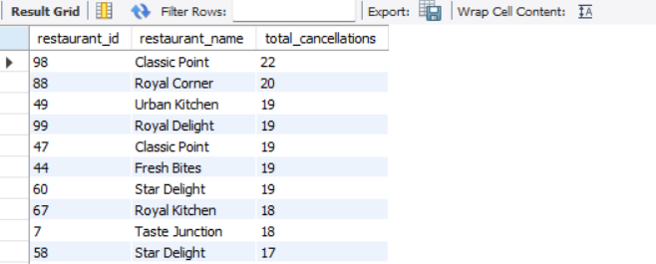
Business Insight
Restaurants with frequent cancellations may face inventory shortages, preparation delays, or operational issues.
Recommendation
- Improve inventory management.
- Monitor restaurant performance.
- Reduce food preparation time.

Q2 Which cities have the highest cancellation rates by percentage?
SELECT
c.city,
COUNT(*) AS total_orders,
SUM(o.status = 'Cancelled') AS cancelled_orders,
ROUND((SUM(o.status = 'Cancelled') * 100.0) / COUNT(*),2) AS cancellation_rate_percentage
FROM orders o
INNER JOIN customers c
ON o.customer_id = c.customer_id
GROUP BY c.city
ORDER BY cancellation_rate_percentage DESC;
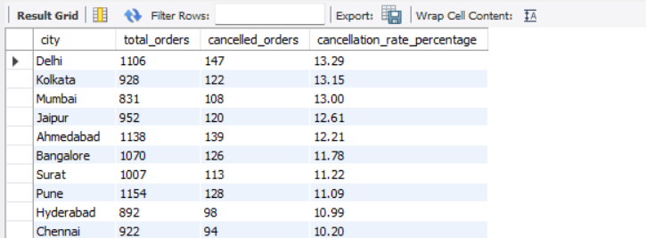
Business Insight
Higher cancellation rates in certain cities indicate location-specific operational challenges.
Recommendation
- Increase delivery capacity.
- Improve customer communication.
- Analyze local operational issues.

Q3 Is there a correlation between delivery delays and cancellations?
SELECT
r.restaurant_name,
ROUND(AVG(TIMESTAMPDIFF(MINUTE,
o.order_time,
o.delivered_time)),2 ) AS average_delivery_time_minutes,
SUM(o.status = 'Cancelled') AS cancelled_orders
FROM orders o
INNER JOIN restaurants r
ON o.restaurant_id = r.restaurant_id
GROUP BY
r.restaurant_id,
r.restaurant_name
ORDER BY
cancelled_orders DESC,
average_delivery_time_minutes DESC;
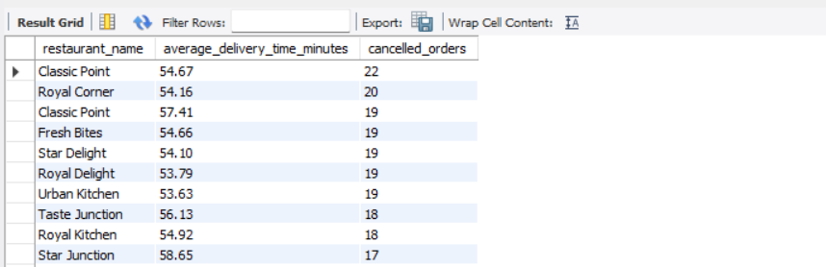
Business Insight
Restaurants with longer delivery times generally experience more cancellations, indicating that delays contribute to order cancellations.
Recommendation
- Reduce delivery times.
- Improve dispatch efficiency.
- Monitor high-risk restaurants.
Q4 On which days and at which times do cancellations peak?
SELECT
DAYNAME(o.order_time) AS day_of_week,
HOUR(o.order_time) AS order_hour,
COUNT(*) AS total_cancellations
FROM orders o
WHERE o.status = 'Cancelled'
GROUP BY
DAYNAME(o.order_time),
HOUR(o.order_time)
ORDER BY total_cancellations DESC;
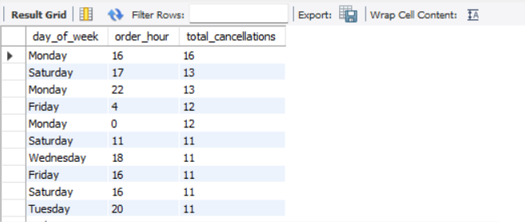

Business Insight
Cancellations increase during specific days and peak hours due to higher order volumes.
Recommendation
- Increase staffing during peak hours.
- Improve resource allocation.
- Prepare restaurants for high-demand periods.

Revenue Optimisation
Q1 Which restaurants generate the highest total revenue?
SELECT
r.restaurant_id,
r.restaurant_name,
ROUND(SUM(p.amount), 2) AS total_revenue
FROM restaurants r
INNER JOIN orders o
ON r.restaurant_id = o.restaurant_id
INNER JOIN payments p
ON o.order_id = p.order_id
WHERE o.status = 'Delivered'
GROUP BY
r.restaurant_id,
r.restaurant_name
ORDER BY total_revenue DESC;
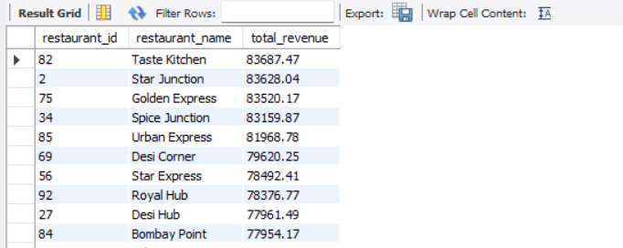
Business Insight
A small number of restaurants contribute significantly to total company revenue.
Recommendation
- Strengthen partnerships with top restaurants.
- Promote lower-performing restaurants.
Q2 Which cities contribute the most to overall company revenue?
SELECT
c.city,
ROUND(SUM(p.amount), 2) AS total_revenue
FROM customers c
INNER JOIN orders o
ON c.customer_id = o.customer_id
INNER JOIN payments p
ON o.order_id = p.order_id
WHERE o.status = 'Delivered'
GROUP BY c.city
ORDER BY total_revenue DESC;
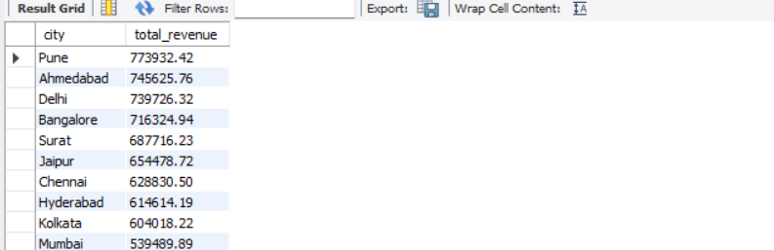
Business Insight
Revenue is concentrated in a few cities, indicating strong market demand in those locations.
Recommendation
- Expand services in high-revenue cities.
- Increase marketing efforts.

Q3 Which payment methods are most popular and most valuable?
SELECT
p.payment_mode,
COUNT(p.payment_id) AS total_transactions,
ROUND(SUM(p.amount), 2) AS total_revenue
FROM payments p
INNER JOIN orders o
ON p.order_id = o.order_id
WHERE o.status = 'Delivered'
GROUP BY p.payment_mode
ORDER BY total_revenue DESC;

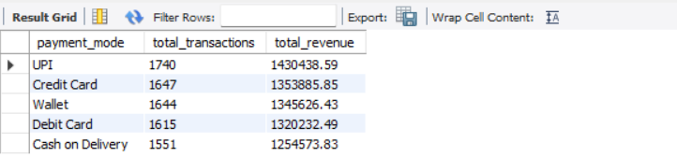

Business Insight
Digital payment methods generate the highest transaction volume and revenue.
Recommendation
- Promote digital payments.
- Offer payment-based cashback.

Q4 What are the monthly revenue trends over the past year?
WITH MonthlyRevenue AS
(
SELECT
DATE_FORMAT(o.order_time, '%M %Y') AS month,
MIN(o.order_time) AS first_order_date,
ROUND(SUM(p.amount), 2) AS monthly_revenue
FROM orders o
INNER JOIN payments p
ON o.order_id = p.order_id
WHERE o.status = 'Delivered'
GROUP BY DATE_FORMAT(o.order_time, '%M %Y')
)
SELECT
month,
monthly_revenue
FROM MonthlyRevenue
ORDER BY first_order_date;
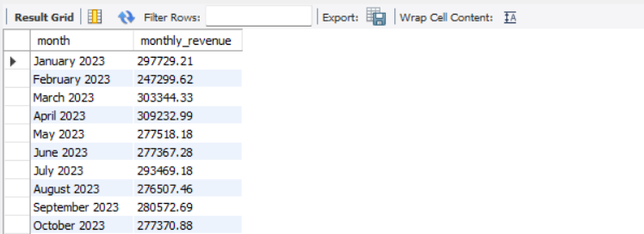
Business Insight
Monthly revenue trends identify seasonal fluctuations and business growth patterns.
Recommendation
- Launch promotions during low-revenue months.
- Prepare additional resources during peak periods.

Customer Retention
Q1 Who are the top 10 most valuable customers by lifetime spending?
WITH CustomerSpending AS
(
SELECT
c.customer_id,
c.customer_name,
ROUND(SUM(p.amount), 2) AS lifetime_spending
FROM customers c
INNER JOIN orders o
ON c.customer_id = o.customer_id
INNER JOIN payments p
ON o.order_id = p.order_id
WHERE o.status = 'Delivered'
GROUP BY
c.customer_id,
c.customer_name
)
SELECT
customer_id,
customer_name,
lifetime_spending
FROM CustomerSpending
ORDER BY lifetime_spending DESC
LIMIT 10;
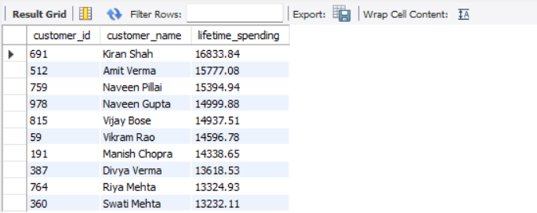
Business Insight
A small group of customers contributes a significant share of overall revenue.
Recommendation
- Introduce loyalty rewards.
- Offer exclusive benefits.

Q2 Which customers order most frequently, and what is their average order value?
SELECT
c.customer_id,
c.customer_name,
COUNT(o.order_id) AS total_orders,
ROUND(AVG(o.order_amount), 2) AS average_order_value
FROM customers c
INNER JOIN orders o
ON c.customer_id = o.customer_id
WHERE o.status = 'Delivered'
GROUP BY
c.customer_id,
c.customer_name
ORDER BY total_orders DESC;

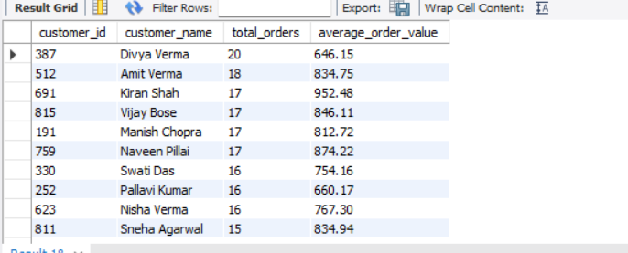
Business Insight
Frequent customers demonstrate strong engagement and higher lifetime value.
Recommendation
- Reward repeat customers.
- Encourage larger order values through bundle offers.

Q3 Which customers have gone inactive in the last 90 days?
SELECT
c.customer_id,
c.customer_name,
MAX(o.order_time) AS last_order_date
FROM customers c
INNER JOIN orders o
ON c.customer_id = o.customer_id
WHERE o.status = 'Delivered'
GROUP BY
c.customer_id,
c.customer_name
HAVING MAX(o.order_time) < DATE_SUB(CURDATE(), INTERVAL 90 DAY)
ORDER BY last_order_date;
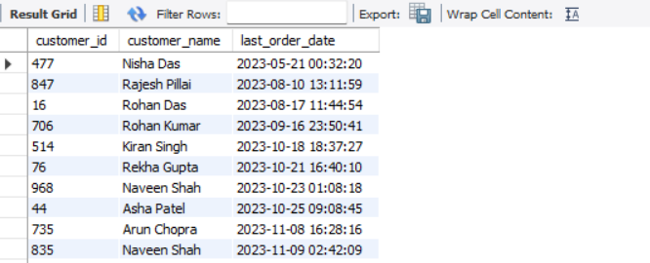
Business Insight
Inactive customers are at risk of churning and require re-engagement.
Recommendation
- Send personalized promotions.
- Offer special discounts.

Q4 What behavioural patterns signal that a customer is about to churn?
SELECT
c.customer_id,
c.customer_name,
COUNT(o.order_id) AS total_orders,
ROUND(AVG(o.order_amount), 2) AS average_order_value,
MAX(o.order_time) AS last_order_date
FROM customers c
INNER JOIN orders o
ON c.customer_id = o.customer_id
GROUP BY
c.customer_id,
c.customer_name
ORDER BY last_order_date ASC;
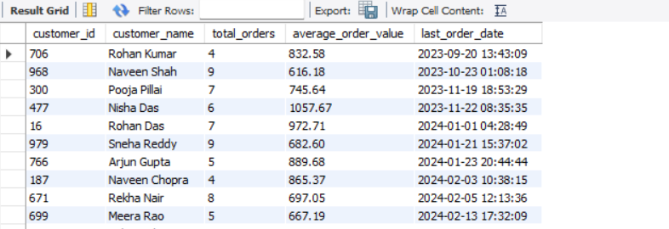
Business Insight
Customers with fewer orders, lower spending, and long periods of inactivity are more likely to churn.
Recommendation
- Identify at-risk customers early.
- Launch targeted retention campaigns.

Delivery Partner Performance
Q1 Who are the fastest delivery partners based on average delivery time?
SELECT
d.partner_id,
d.partner_name,
ROUND(AVG(TIMESTAMPDIFF(MINUTE,
o.order_time,
o.delivered_time)),2) AS average_delivery_time_minutes
FROM orders o
INNER JOIN delivery_partners d
ON o.partner_id = d.partner_id
WHERE o.status = 'Delivered'
GROUP BY
d.partner_id,
d.partner_name
ORDER BY average_delivery_time_minutes ASC;
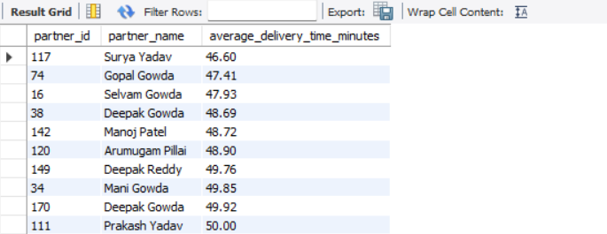
Business Insight
Fast delivery partners consistently complete orders quickly, improving customer satisfaction.
Recommendation
- Reward top-performing partners.
- Share best practices with the team.

Q2 Which partners handle the highest volume of successful deliveries?
SELECT
d.partner_id,
d.partner_name,
COUNT(o.order_id) AS successful_deliveries
FROM orders o
INNER JOIN delivery_partners d
ON o.partner_id = d.partner_id
WHERE o.status = 'Delivered'
GROUP BY
d.partner_id,
d.partner_name
ORDER BY successful_deliveries DESC;
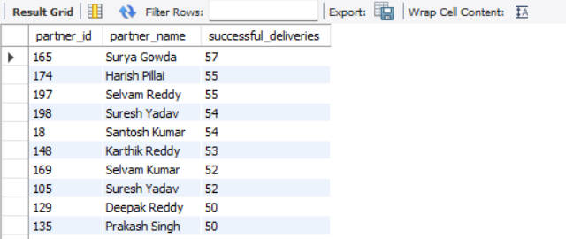
Business Insight
Partners completing the most successful deliveries are key contributors to operational efficiency.
Recommendation
- Recognize high-performing partners.
- Balance workloads across the delivery team.

Q3 Which partners are associated with the most cancellations or delays?
SELECT
d.partner_id,
d.partner_name,
SUM(o.status = 'Cancelled') AS total_cancellations,
ROUND(AVG(TIMESTAMPDIFF(MINUTE,
o.order_time,
o.delivered_time)),2) AS average_delivery_time
FROM orders o
INNER JOIN delivery_partners d
ON o.partner_id = d.partner_id
GROUP BY
d.partner_id,
d.partner_name
ORDER BY
total_cancellations DESC,
average_delivery_time DESC;
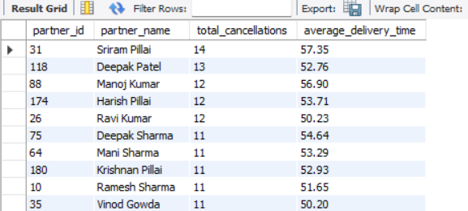
Business Insight
Partners with high cancellation counts or longer delivery times may require operational support or performance improvements.
Recommendation
- Review partner performance regularly.
- Provide additional training.
- Optimize route allocation.
Q4 What is the average customer rating received per delivery partner?
SELECT
d.partner_id,
d.partner_name,
ROUND(AVG(r.customer_rating), 2) AS average_rating
FROM delivery_partners d
INNER JOIN orders o
ON d.partner_id = o.partner_id
INNER JOIN ratings r
ON o.order_id = r.order_id
GROUP BY
d.partner_id,
d.partner_name
ORDER BY average_rating DESC;
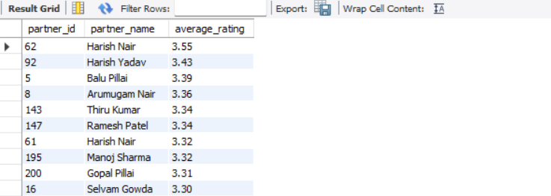
Business Insight
Higher customer ratings indicate better delivery service quality and customer satisfaction.
Recommendation
- Reward highly rated partners.
- Coach lower-rated partners to improve service quality.

10. Recommendations

The following business recommendations are proposed.

Recommendation 1
Increase delivery partner availability during peak hours.
Expected Result:
Reduced delivery delays.

Recommendation 2
Improve restaurant preparation efficiency.
Expected Result:
Faster deliveries.

Recommendation 3
Launch customer loyalty programs.
Expected Result:
Higher customer retention.

Recommendation 4
Optimize delivery routes.
Expected Result:
Lower operational cost.

Recommendation 5
Expand services in high-revenue cities.
Expected Result:
Increased company revenue.

Recommendation 6
Monitor cancellation trends monthly.
Expected Result:
Reduced cancellation rates.

11. Conclusion
The Smart Delivery Operations Analytics System successfully demonstrates the practical application of SQL in solving real-world business problems. Through relational database design, data import, validation, cleaning, and analytical querying, meaningful insights were generated to improve delivery operations, customer satisfaction, and revenue performance.
The project showcases a broad range of SQL concepts—from basic queries to advanced analytical techniques such as joins, subqueries, Common Table Expressions (CTEs), window functions, views, and stored procedures. The analysis supports informed decision-making and provides actionable recommendations for business improvement.
Overall, this project strengthened practical skills in database management, SQL analytics, and business reporting, while illustrating how data can be transformed into valuable insights for organizational growth.

